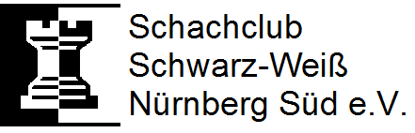
chess without borders
rapid chess tournament
refugees wellcome
charity tournament supporting help for refugees

Saturday, 14.05.2016
start: 10.00 a.m. end of registration: 9.30 a.m.

location:
Südstadtforum
Siebenkeesstraße 4
90459 Nürnberg

entry fee:  adults 10 € - youth 5 € (1998 or younger)  refugees free of charge! | prizes:  1. rank – 50 €  2. rank – 30 €  3. rank – 20 €

7 rounds of swiss system, Buchholz-scoring as tie-break
20 minutes time for each player
computer aided drawing

The prize-money was donated by our member Leon Heinrich!
Any surplus from entry fees or cake sales will go completely to the benefit of the asylothek.
www.asylothek.de www.facebook.com/asylothek
advance registration via e-mail requested but not mandatory!
(e-mail: spielleiter@sw-nuernberg-sued.net)
tournament administrator Richard Saathoff
Drawing according to DWZ-database of schachbund.de on the 14.05.2016

